Packet Tracer - Use Cisco IOS Show Commands

# Objectives

* Use Cisco IOS **show** commands

# Background / Scenario

The Cisco IOS **show** commands are used extensively when working with Cisco equipment. In this activity, you will use the **show** commands on a router located at an ISP.

# Instructions

## Connect to the ISP Cisco 4321 router.

In this part, you will use the terminal emulation software on ISP PC to connect to the Cisco 4321 router.

* + - 1. Click **ISP PC**.
      2. Click **Desktop** tab. Select **Terminal**. Review the terminal configuration and click **OK** to continue.
      3. The **ISPRouter >** prompt indicates that you are in user EXEC mode. Press Enter if the prompt did not display.

## Explore the show commands.

Use the information displayed by these **show** commands to answer the following questions.

### Explore show commands in User EXEC mode.

Open configuration window

* + - 1. Type **show ?** at the prompt.

#### Question:

List a few more **show** commands that are available in the user EXEC mode.

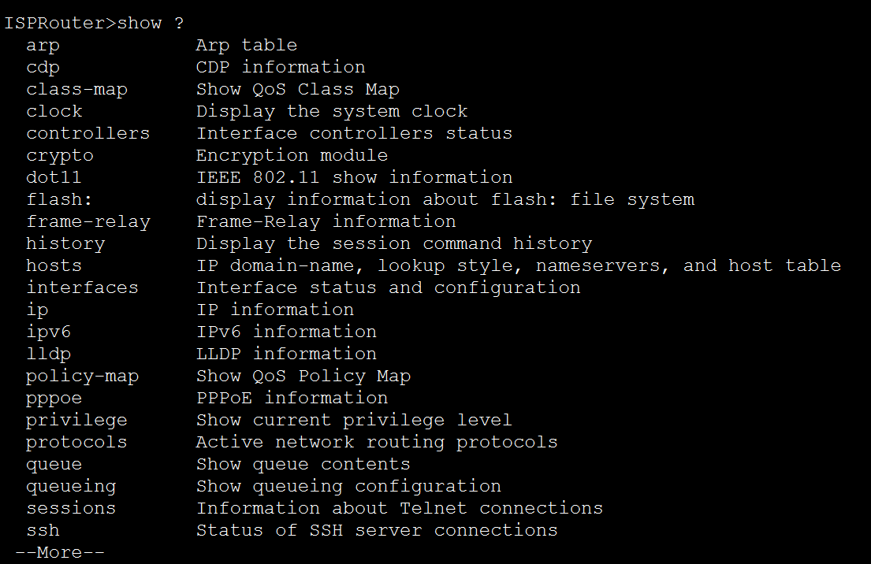

* + - 1. Enter **show arp** at the prompt.

#### Question:

Record the MAC address and the IP address listed.



Enter **show flash** at the prompt.

#### Question:

Record the IOS image listed:

* + - 1. Enter **show ip route** at the prompt.

#### Question:

How many routes are listed in the table?

* + - 1. Enter **show interfaces** at the prompt.

#### Question:

Which interface is up and running?

| Interface | Status | Protocol |
| --- | --- | --- |
| GigabitEthernet 0/0/0 | Up | Up |
| GigabitEthernet 0/0/1 | Down | Down |
| Serial0/1/0 | Down | Down |
| Serial0/1/1 | Down | Down |

* + - 1. Enter **show ip interface** at the prompt.

#### Question:

According to the **show ip interface** output, which interface is connected?

* + - 1. Enter **show version** at the prompt.

#### Question:

What technology package is enabled currently on the router?

Enter **show protocols** at the prompt.

#### Question:

Which protocols are enabled currently on the router?

* + - 1. Enter **show running-config** at the prompt.

#### Question:

What is the output?

Type your answers here.

### Explore the show commands in privileged EXEC mode.

* + - 1. Enter **enable** at the prompt to enter the privileged EXEC mode.

#### Question:

List some additional **show** commands in this mode.

Type your answers here.

* + - 1. Enter **show running-config** at the prompt.

#### Question:

What is the output?

Close configuration window

# Answer Key

* 1. **Connect to the ISP Cisco 4321 router.**
  2. **Explore the show commands.**
     1. **Explore show commands in User EXEC mode.**

List a few more **show** commands that are available in the user EXEC mode.

**Answers will vary. These are a few of available show commands: show cdp, show class-map, show clock**

Record the MAC address and the IP address listed.

**Answers may vary. 0001.96CD.2501: 209.165.201.1, 000A.F3C7.5CD3: 209.165.201.5, and 0002.162C.67A7: 209.165.201.10**

Record the IOS image listed:

**isr4300-universalk9.03.16.05.S.155-3.S5-ext.SPA.bin**

How many routes are listed in the table?

**2**

Which interface is up and running?

| **Interface** | **Status** | **Protocol** |
| --- | --- | --- |
| GigabitEthernet 0/0/0 | Up | **Up** |
| GigabitEthernet 0/0/1 | **Administratively Down** | Down |
| Serial0/1/0 | **Down** | **Down** |
| Serial0/1/1 | Down | **Down** |

According to the **show ip interface** output, which interface is connected?

**GigabitEthernet0/0/0**

What technology package is enabled currently on the router?

**ipbasek9 and securityk9**

Which protocols are enabled currently on the router?

**Internet Protocol routing is enabled. Line protocol is up for GigabitEthernet0/0/0.**

What is the output?

**ISPRouter> show running-config**

**^**

**% Invalid input detected at '^' marker.**

* + 1. **Explore the show commands in privileged EXEC mode.**

List some additional **show** commands in this mode.

**Answers will vary. Some example of the show commands are: show aaa, show access-list, show file**

What is the output?

**The output displays the current configurations and settings.**

End of document